CSA1503-Cloud computing and big data analytics
Aim
To develop a simple cloud-based Student Attendance System using Zoho Creator as the cloud service provider to demonstrate the Software as a Service (SaaS) model.
Procedure
- Sign in to Zoho Creator using a Zoho account.
- Click Create New Application and select Blank Application.
- Enter the application name as Student Attendance System.
- Create a new Form named Student Attendance.
- Add the following fields to the form:
  - Student Name
  - Roll Number
  - Course
  - Present (Number)
  - Absent (Number)
  - Total Classes (Number)
  - Attendance Percentage (Formula/Number)
  - OD Request (Yes/No)
  - Grade (Drop-down: A+, A, B+, B, C)
- Configure a formula to calculate the attendance percentage;
- Save the form and create a Report to display all student attendance records.
- Enter sample student attendance details and save the records.
- Verify that the records are stored in the Zoho cloud database and displayed in the report.
- Access the application from any web browser to demonstrate the SaaS functionality.
Result
A cloud-based Student Attendance System was successfully developed using Zoho Creator.
Input 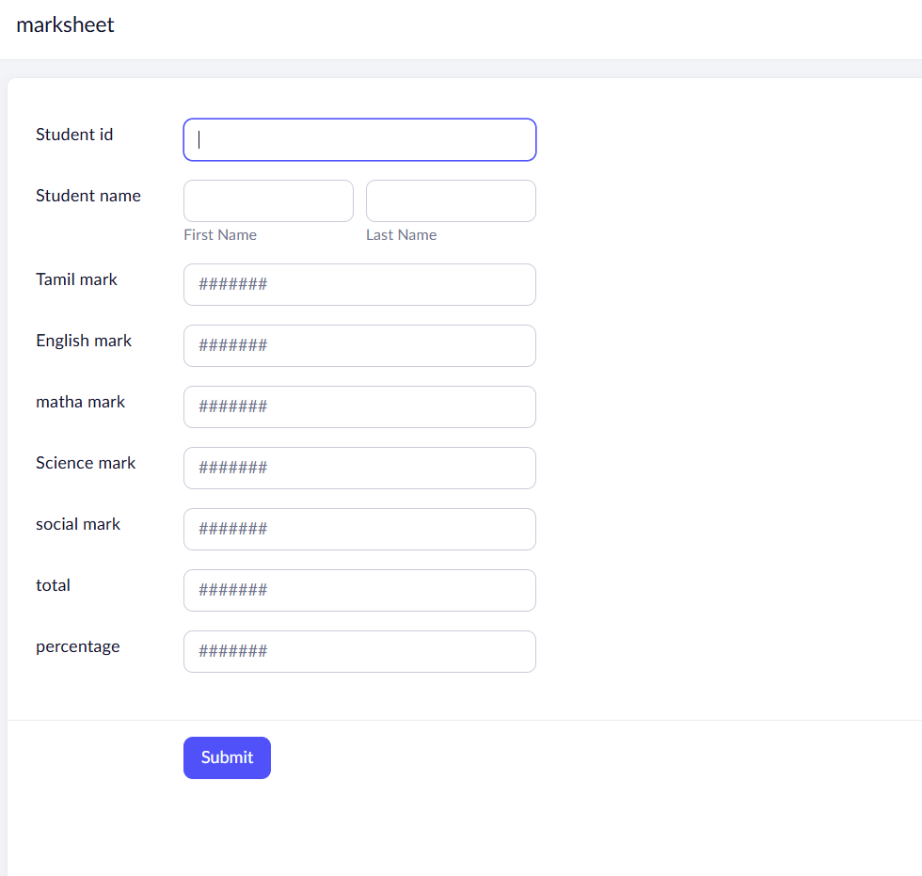
Output
